# API说明

## API

### 连接

|  |  |  |  |  |  |
| --- | --- | --- | --- | --- | --- |
| open |  |  |  |  |  |
| 说明 | 打开设备建立连接 | | | | |
| 输入参数 | 地址 | 设备IP |  |  |  |
|  |  |  |  |  |  |
| 输出参数 | 设备id | 设备控制句柄 |  |  |  |
|  |  |  |  |  |  |
|  |  |  |  |  |  |

|  |  |  |  |  |  |
| --- | --- | --- | --- | --- | --- |
| close |  |  |  |  |  |
| 说明 | 关闭设备连接 | | | | |
| 输入参数 | 设备id |  |  |  |  |
|  |  |  |  |  |  |
| 输出参数 | 无 |  |  |  |  |
|  |  |  |  |  |  |
|  |  |  |  |  |  |

### 移动

|  |  |  |  |  |  |
| --- | --- | --- | --- | --- | --- |
| home |  |  |  |  |  |
| 说明 | 设备回原点 | | | | |
| 输入参数 | 设备id |  |  |  |  |
|  | v | 回零速度 |  |  |  |
| 输出参数 | 设备id |  |  |  |  |
|  |  |  |  |  |  |
|  |  |  |  |  |  |

|  |  |  |  |  |  |
| --- | --- | --- | --- | --- | --- |
| goto |  |  |  |  |  |
| 说明 | 运动到目标位置，目标位置是自定义坐标系 | | | | |
| 输入参数 | 设备id |  |  |  |  |
|  | x |  |  |  |  |
|  | y |  |  |  |  |
|  | z |  |  |  |  |
|  | v |  |  |  |  |
| 输出参数 | 设备id |  |  |  |  |
|  |  |  |  |  |  |
|  |  |  |  |  |  |

|  |  |  |  |  |  |
| --- | --- | --- | --- | --- | --- |
| origin_to |  |  |  |  |  |
| 说明 | 到目标位置，并将目标位置设置为自定义原点 | | | | |
| 输入参数 | 设备id |  |  |  |  |
|  | x |  |  |  |  |
|  | y |  |  |  |  |
|  | z |  |  |  |  |
|  | v |  |  |  |  |
| 输出参数 | 设备id |  |  |  |  |
|  |  |  |  |  |  |
|  |  |  |  |  |  |

|  |  |  |  |  |  |
| --- | --- | --- | --- | --- | --- |
| step |  |  |  |  |  |
| 说明 | 单步相对运动 | | | | |
| 输入参数 | 设备id |  |  |  |  |
|  | x |  |  |  |  |
|  | y |  |  |  |  |
|  | z |  |  |  |  |
|  | v |  |  |  |  |
|  | n | 单步次数，如果单步次数大于1，需要等待后续的continue操作 |  |  |  |
| 输出参数 | 设备id |  |  |  |  |
|  |  |  |  |  |  |
|  |  |  |  |  |  |

|  |  |  |  |  |  |
| --- | --- | --- | --- | --- | --- |
| trace |  |  |  |  |  |
| 说明 | 轨迹移动。  行、列，扫描和蛇形移动中，x,y表示运动的方向，取值为+/-1,z为0。  斜线移动中，x,y,z表示目标位置。 | | | | |
| 输入参数 | 设备id |  |  |  |  |
|  | type | zigzagx | 列扫描 |  |  |
|  |  | zigzagy | 行扫描 |  |  |
|  |  | snakex | 列蛇形 |  |  |
|  |  | snakey | 行蛇形 |  |  |
|  |  | slope | 斜线 | 斜线时，的步进次数是X,Y方向的最小值 |  |
|  | x |  |  |  |  |
|  | y |  |  |  |  |
|  | z |  |  |  |  |
|  | v |  |  |  |  |
|  |  |  |  |  |  |
| 输出参数 | 设备id |  |  |  |  |
|  |  |  |  |  |  |
|  |  |  |  |  |  |

|  |  |  |  |  |  |
| --- | --- | --- | --- | --- | --- |
| continue |  |  |  |  |  |
| 说明 | 进行下一步动作 | | | | |
| 输入参数 | 设备id |  |  |  |  |
|  |  |  |  |  |  |
| 输出参数 | 设备id |  |  |  |  |
|  |  |  |  |  |  |
|  |  |  |  |  |  |

|  |  |  |  |  |  |
| --- | --- | --- | --- | --- | --- |
| requestX |  |  |  |  |  |
| 说明 | 执行停止或紧急停止 | | | | |
| 输入参数 | 设备id |  |  |  |  |
|  | cmd | stop | 停止 |  |  |
|  |  | estop | 紧急停止 |  |  |
| 输出参数 | 设备id |  |  |  |  |
|  |  |  |  |  |  |
|  |  |  |  |  |  |

### 配置

|  |  |  |  |  |  |
| --- | --- | --- | --- | --- | --- |
| config |  |  |  |  |  |
| 说明 | 进行参数配置 | | | | |
| 输入参数 | 设备id |  |  |  |  |
|  | item | origin | 配置起点 |  |  |
|  |  | whz | 配置工作空间，x,y,z分别表示高，宽，深度 |  |  |
|  |  | dwdhdz | 配置步进长度，x,y,z分别表示，x,y,z方向的步进 |  |  |
|  | x |  |  |  |  |
|  | y |  |  |  |  |
|  | z |  |  |  |  |
| 输出参数 | 设备id |  |  |  |  |
|  |  |  |  |  |  |
|  |  |  |  |  |  |

|  |  |  |  |  |  |
| --- | --- | --- | --- | --- | --- |
| configRV |  |  |  |  |  |
| 说明 | 配置行列扫描时的回扫速度 | | | | |
| 输入参数 | 设备id |  |  |  |  |
|  | rv | mm/s |  |  |  |
| 输出参数 | 设备id |  |  |  |  |
|  |  |  |  |  |  |
|  |  |  |  |  |  |

|  |  |  |  |  |  |
| --- | --- | --- | --- | --- | --- |
| configGap |  |  |  |  |  |
| 说明 | 配置Z轴的间隙尺寸和间隙速度 | | | | |
| 输入参数 | 设备id |  |  |  |  |
|  | gap | mm |  |  |  |
|  | gapspeed | mm/s |  |  |  |
| 输出参数 | 设备id |  |  |  |  |
|  |  |  |  |  |  |
|  |  |  |  |  |  |

|  |  |  |  |  |  |
| --- | --- | --- | --- | --- | --- |
| configRst |  |  |  |  |  |
| 说明 | 恢复默认设置 | | | | |
| 输入参数 | 设备id |  |  |  |  |
|  | 默认参数 | TBD |  |  |  |
| 输出参数 | 设备id |  |  |  |  |
|  |  |  |  |  |  |
|  |  |  |  |  |  |

### 查询

|  |  |  |  |  |  |
| --- | --- | --- | --- | --- | --- |
| queryConfig |  |  |  |  |  |
| 说明 | 查询配置 | | | | |
| 输入参数 | 设备id |  |  |  |  |
|  | item | origin | 起点 |  |  |
|  |  | whz | 工作空间尺寸 |  |  |
|  |  | dwdhdz | 步进大小 |  |  |
| 输出参数 | 设备id |  |  |  |  |
|  | x |  |  |  |  |
|  | y |  |  |  |  |
|  | z |  |  |  |  |

|  |  |  |  |  |  |
| --- | --- | --- | --- | --- | --- |
| queryRV |  |  |  |  |  |
| 说明 | 查询回扫速度 | | | | |
| 输入参数 | 设备id |  |  |  |  |
|  |  |  |  |  |  |
| 输出参数 | 设备id |  |  |  |  |
|  | rv |  |  |  |  |
|  |  |  |  |  |  |

|  |  |  |  |  |  |
| --- | --- | --- | --- | --- | --- |
| queryGap |  |  |  |  |  |
| 说明 | 查询Z轴间隙 | | | | |
| 输入参数 | 设备id |  |  |  |  |
|  |  |  |  |  |  |
| 输出参数 | 设备id |  |  |  |  |
|  | gap |  |  |  |  |
|  | gapspeed |  |  |  |  |

|  |  |  |  |  |  |
| --- | --- | --- | --- | --- | --- |
| queryPose |  |  |  |  |  |
| 说明 | 查询当前位姿 | | | | |
| 输入参数 | 设备id |  |  |  |  |
|  |  |  |  |  |  |
| 输出参数 | 设备id |  |  |  |  |
|  | x |  |  |  |  |
|  | y |  |  |  |  |
|  | z |  |  |  |  |
|  | vx |  |  |  |  |
|  | vy |  |  |  |  |
|  | vz |  |  |  |  |

## 举例

### 回原点

* open
* home
* Close

### X方向步进

* open
* step x:10,y:0,z:0,v:10,n:1
* close

### X方向步进n

* open
* step x:10,y:0,z:0,v:10,n:3
* continue
* continue
* Close

#### 说明：

* 以10mm步进向X方向步进3次
* 第一次step发出后执行第一个步进，然后等待
* 后面两次continue完成剩下的两个步进
* 处于步进中间过程中可以通过 requestX cmd:stop 来终止步进过程

### 到目标位置

* open
* goto x:10,y:0,z:0,v:10
* Close

### 执行行扫描

* open
* trace item:zigzigy,x:1,y,1,z:0,v:10
* continue
* continue
* ...
* Close

#### 说明：

* 行扫描时x,y,z表示的是步进方向
* 步进数值为 config item:dwdhdz
* X:1,Y:1表示行间隔dh,列间隔dw(如果X:-1,表示行扫描方向和dw相反)

### 待定

* 行列扫描和蛇形移动是否有Z方向的动作？
* 步进运动中是否会穿插其他单步动作，例如，在执行行扫描过程中，每步的间隙是否会有Z轴的动作？

## 附：轨迹描述

平面坐标系：

* 运动空间 a * b

### 横向点阵型移动

1. 从起点开始进行横向移动，移动距离d1，等待继续
2. 从起点开始到终点总共移动n次
3. 移动到横向的终点后自动移动到下一行，行间距是d2,等待继续
4. 纵向共移动m次

* 纵向点阵移动时，先进行纵向的移动，然后再进行横向的移动

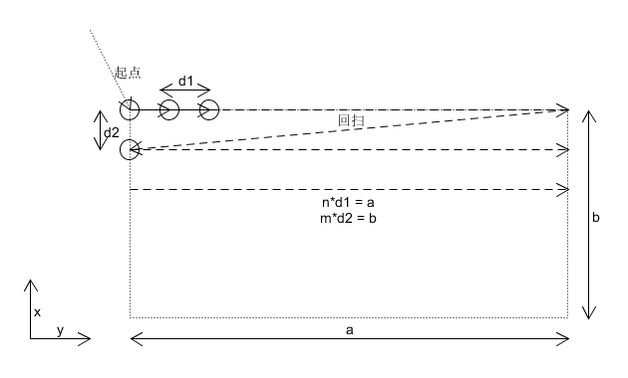

### 横向蛇形移动

1. 从起点开始
2. 移动d1然后等待
3. 纵向移动b然后等待
4. 横向移动d1然后等待
5. 纵向回到起点所在的行，等待
6. 重复2
7. 纵向的蛇形移动先移动d2,然后横向移动a

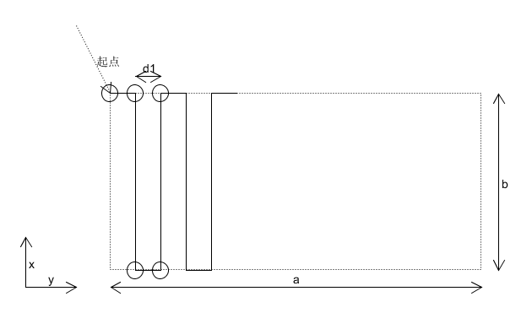

### 斜线移动

* 从起点开始
* 单步移动(d2,d1)直到终点
* 要求横向和纵向移动的步数相等，即dX = k * d2, dY = k * d1
* d1, d2 区分正负

